1 Write a C program to perform the arithmetic operations using Functions.
#include <stdio.h>
int add(int num1, int num2) {
return num1 + num2;
}
int subtract(int num1, int num2) {
return num1 - num2;
}
int multiply(int num1, int num2) {
return num1 * num2;
}
float divide(int num1, int num2) {
if (num2 == 0) {
printf("Error: Division by zero is not allowed.\n");
return 0.0;
}
return (float)num1 / num2;
}
int main() {
int number1, number2;

printf("Enter the first integer: ");
scanf("%d", &number1);

printf("Enter the second integer: ");
scanf("%d", &number2);

printf("\nArithmetic Operations:\n");
printf("Addition: %d + %d = %d\n", number1, number2, add(number1, number2));
printf("Subtraction: %d - %d = %d\n", number1, number2, subtract(number1, number2));
printf("Multiplication: %d * %d = %d\n", number1, number2, multiply(number1, number2));
printf("Division: %d / %d = %.2f\n", number1, number2, divide(number1, number2));
return 0;
}
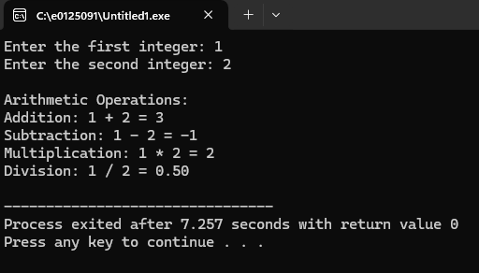

2. Write a C program to find the factorial of a given number using Functions

#include <stdio.h>
long long int calculateFactorial(int n) {
long long int factorial = 1;
if (n < 0) {
printf("Error: Factorial is not defined for negative numbers.\n");
return -1;
}
else if (n == 0) {
return 1;
}
else {
for (int i = 1; i <= n; i++) {
factorial *= i;
}
return factorial;
}
}
int main() {
int number;
long long int result;

printf("Enter a non-negative integer: ");
scanf("%d", &number);

result = calculateFactorial(number);

if (result != -1) {
printf("Factorial of %d is: %lld\n", number, result);
}
return 0;
}
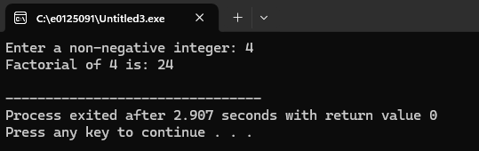

3. Write a C program to print the Fibonacci Series using Functions
#include <stdio.h>
void printFibonacci(int n) {
int num1 = 0, num2 = 1, nextNum, i;

if (n <= 0) {
printf("Please enter a positive integer for the number of terms.\n");
return;
}
printf("Fibonacci Series: ");

if (n >= 1) {
printf("%d", num1);
}
if (n >= 2) {
printf(", %d", num2);
}

for (i = 3; i <= n; i++) {
nextNum = num1 + num2;
printf(", %d", nextNum);
num1 = num2;
num2 = nextNum;
}
printf("\n");
}
int main() {
int numTerms;
printf("Enter the number of Fibonacci terms to generate: ");
scanf("%d", &numTerms);
printFibonacci(numTerms);
return 0;
}

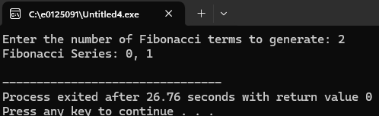

4. Write a C program to find the factorial of a given number using recursive Functions.
#include <stdio.h>
int factorial(int n) {

if (n == 0) {
return 1;
}

else {
return n * factorial(n - 1);
}
}

int main() {
int num;
printf("Enter a non-negative integer: ");
scanf("%d", &num);
if (num < 0) {
printf("Factorial of a negative number is not defined.\n");
} else {
printf("The factorial of %d is %d.\n", num, factorial(num));
}

return 0;
}

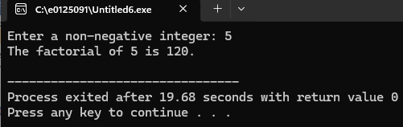

5. Write a C program to print the Fibonacci Series using recursive Functions
#include <stdio.h>

int fibonacci(int n) {
if (n <= 1) {
return n;
} else {
return fibonacci(n - 1) + fibonacci(n - 2);
}
}

int main() {
int num_terms;

printf("Enter the number of terms for the Fibonacci series: ");
scanf("%d", &num_terms);

if (num_terms < 0) {
printf("Please enter a non-negative number of terms.\n");
} else {
printf("Fibonacci Series:\n");
for (int i = 0; i < num_terms; i++) {
printf("%d ", fibonacci(i));
}
printf("\n");
}

return 0;
}
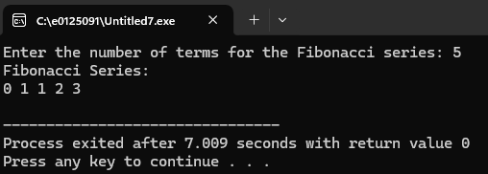

6. Write a C program to swap two numbers using Call by Value and Call by Reference
#include <stdio.h>

void swapByValue(int num1, int num2) {
int temp = num1;
num1 = num2;
num2 = temp;
printf("Inside swapByValue function: num1 = %d, num2 = %d\n", num1, num2);
}

void swapByReference(int *num1, int *num2) {
int temp = *num1;
*num1 = *num2;
*num2 = temp;
printf("Inside swapByReference function: *num1 = %d, *num2 = %d\n", *num1, *num2);
}

int main() {
int a = 10, b = 20;

printf("Original values in main: a = %d, b = %d\n", a, b);
printf("\n--- Calling swapByValue ---\n");
swapByValue(a, b);
printf("After swapByValue in main: a = %d, b = %d\n", a, b);
a = 10, b = 20;
printf("\n--- Calling swapByReference ---\n");
swapByReference(&a, &b);
printf("After swapByReference in main: a = %d, b = %d\n", a, b);
return 0;
}
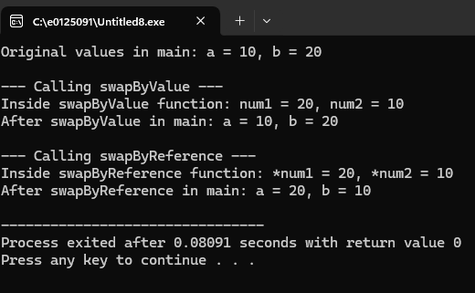
7. Write a C program to perform Files reading, writing and updating.

#include <stdio.h>
#include <stdlib.h>
#include <string.h>

int main() {
FILE *fptr;
char data[100];
char file_name[] = "example.txt";

fptr = fopen(file_name, "w");
if (fptr == NULL) {
printf("Error opening file for writing!\n");
exit(1);
}
printf("Writing to %s...\n", file_name);
fprintf(fptr, "This is the first line.\n");
fputs("This is the second line.\n", fptr);
fclose(fptr);
printf("Data written successfully.\n\n");

fptr = fopen(file_name, "r"); // Open in read mode ("r")
if (fptr == NULL) {
printf("Error opening file for reading!\n");
exit(1);
}
printf("Reading from %s:\n", file_name);
while (fgets(data, sizeof(data), fptr) != NULL) {
printf("%s", data);
}
fclose(fptr);
printf("\nData read successfully.\n\n");

fptr = fopen(file_name, "a");
if (fptr == NULL) {
printf("Error opening file for appending!\n");
exit(1);
}
printf("Appending to %s...\n", file_name);
fprintf(fptr, "This is an appended line.\n");
fclose(fptr);
printf("Data appended successfully.\n\n");
fptr = fopen(file_name, "r");
if (fptr == NULL) {
printf("Error opening file for reading after append!\n");
exit(1);
}
printf("Reading updated %s:\n", file_name);
while (fgets(data, sizeof(data), fptr) != NULL) {
printf("%s", data);
}
fclose(fptr);
printf("\nUpdated data read successfully.\n\n");

if (fptr == NULL) {
printf("Error opening file for updating!\n");
exit(1);
}

printf("Updating a specific part of %s...\n", file_name);

char search_text[] = "second";
char replace_text[] = "modified";
long pos = 0;
int found = 0;

while (fgets(data, sizeof(data), fptr) != NULL) {
if (strstr(data, search_text) != NULL) {
found = 1;

fseek(fptr, pos, SEEK_SET);

fprintf(fptr, "This is the %s line.\n", replace_text);
break;
}
pos = ftell(fptr);
}

if (found) {
printf("File updated successfully.\n");
} else {
printf("Text to update not found.\n");
}
fclose(fptr);

fptr = fopen(file_name, "r");
if (fptr == NULL) {
printf("Error opening file for final read!\n");
exit(1);
}
printf("\nReading final updated %s:\n", file_name);
while (fgets(data, sizeof(data), fptr) != NULL) {
printf("%s", data);
}
fclose(fptr);
printf("\nFinal updated data read successfully.\n");

return 0;
}
